FIXED BAYONETS:

A COMPLETE SYSTEM OF

FENCE FOR THE BRITISH MAGAZINE RIFLE,

EXPLAINING THE USE OF POINT, EDGES, AND BUTT, BOTH IN OFFENCE AND DEFENCE;

COMPRISING ALSO
A GLOSSARY OF ENGLISH, FRENCH, AND ITALIAN TERMS COMMON TO
THE ART OF FENCING,
WITH A
BIBLIOGRAPHICAL LIST OF WORKS AFFECTING THE BAYONET.

BY
ALFRED HUTTON,

LATE CAPT. KING'S DRAGOON GUARDS ;
AUTHOR OF “SWORDSMANSHIP,” “BAYONET-FENCING AND SWORD PRACTICE,”
“COLD STEEL,” ETC.

ILLUSTRATED BY J. E. BREUN.

LONDON:
WILLIAM CLOWES AND SONS, LIMITED,
13, CHARING CROSS. 189O.
(All rights reserved.)

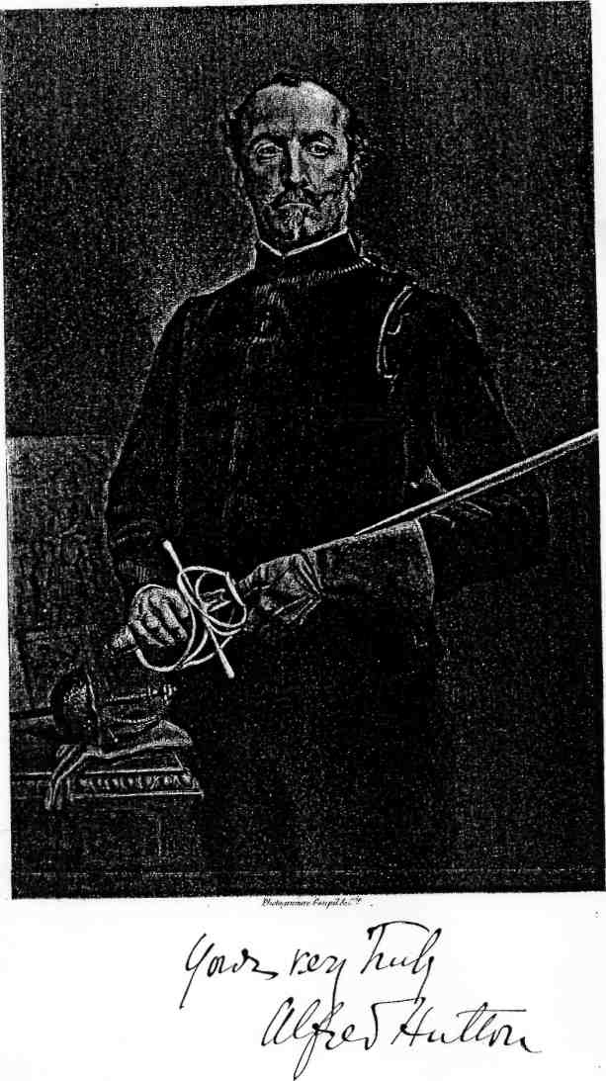

PREFACE.

My recent work, “Cold Steel,” has received a welcome from many of the most important journals, both English and foreign, so unexpectedly warm and generous, that I feel emboldened to lay before the public a companion to it, the matter of which I was, for various reasons, unable to include in the book itself.
The weapon I select for present discussion is our new British Magazine Rifle and its Bayonet. I add, further, what I hope may prove of interest to the fencing world - since it has hardly been attempted at all in the English language during this century - a glossary of English, French, and Italian terms of fence, together with a list of as many known treatises affecting the bayonet as I have been able to procure, in which, following the example of Gomard, I include English translations of the many foreign titles that occur therein ; and I ought to add, that in compiling this latter portion of my work I am much indebted to my friend, Mr. Egerton Castle, for a large amount of valuable information and assistance.
The science of rifle shooting has - thanks to the talent, energy, and research of the officers of our School of Musketry, at Hythe - attained such a degree of excellence and precision that it would be almost an impertinence on my part, old Musketry Instructor though I am, to offer any suggestions regarding that aspect of the Arm.
Not so, however, when it comes to be viewed in the light of hand-to-hand combat - regarded, in fact, as cold steel; here the musket and bayonet have been for years strangely neglected. A very small number of English works on the subject have from time to time appeared, but they seem to have been for the most part nipped in the bud by official frost, and so are very difficult to meet with; indeed, with the exception of Captain Anthony Gordon's “Treatise on the Science of Defence for the Sword, Bayonet, or Pike,” 1805, which is more interesting as a curiosity than useful as a work of reference; Lieutenant (now Sir Richard) Burton's “Complete System of Bayonet Exercise,” 1853; and my own little books, the first of which I printed at Simla in 1862, we have produced practically nothing. The American work by McClellan, 1862, we English cannot, of course, lay claim to; nor need we wish to do so, as it is confessedly not original, but a mere translation of the work of a foreign author.
On the Continent, many such works have appeared during the present century, mainly in the first half of it - in German, French, Italian, Spanish, and even Russian - but the subject never seems to have found much favour with the teachers of the art of fence; the reason, no doubt, being that the practice weapons heretofore in use have been of a pattern so cumbersome and fatiguing as to appeal but very slightly to the fancy of the denizens of the “Salles d'Armes.”
The weak point of our new weapon is its shortness as compared with its predecessors, the old muzzle - loading Enfield with its bayonet being six feet one inch in length, and the Henry-Martini being five feet seven and a half, while the present rifle with bayonet fixed, measures only five feet one; the difference in point of reach between five feet one and six feet one is obvious, and it should be noticed that certain Continental armies, notably the French, are adhering to the longer arm. As a set-off to this, however, we have, thanks to the reduced weight, a much more handy weapon, and we have, also, a more varied scope of attack, defence, and riposte. We have - first, the point; second, the two edges, to the use of which the new 'Bayonet Exercise' does not point in any way, although, be it observed, the small-bore rifle, of which I now write, must have advanced considerably further than a state of mere contemplation at the time when that somewhat meagre little manual was in process of production; and, thirdly, we have the butt, the use of which is advised, and in a measure explained, by various Continental writers, notably Gomard, Chapitre, and Chatin, and was advanced still further in 1882, by myself, in my ' Bayonet - fencing and Sword Practice,' which I brought out with the distinct purpose of furthering the views of the then Inspector and Assistant Inspector of Gymnasia, who happened to be personal friends of mine, but which the author of this same manual utterly ignores. While for the purpose of defence we have the whole length of the woodwork of the rifle from nose-cap to heel-plate, as in some cases even the butt itself may, nay more, must, be utilised for this purpose; the blade should never be so used, either according to the rules of fencing or according to the dictates of common sense, as it essentially represents the "foible," or weakest part of the weapon, and is legitimately employed solely for attack, and for attack on the person only.
Before entering upon the discussion of the management of our new arm, I shall glance critically at the Regulation Exercise recently brought into authorised use.

Alfred Hutton.
Army and Navy Club, February, 1890,

CONTENTS.

CRITICAL REMARKS ON "PHYSICAL DRILL WITH ARMS,
AND BAYONET EXERCISE," 1889 1
FIXED BAYONETS 13
Our Weapon in Attack 14
Our Weapon in Defence 17
The Guard 18
The Resting Guard 20
The Volte ”
Change Guard 23
The Point 26
Thrust 27
Prime-Thrust 28
Throw ”
Shorten Arms 35
Change of Engagement 36
Disengagement and Derobement ”
Cut Over 39
Parries against Point 40
Parry of Quarte 41
Parry of Sixte .. ”
Parry of Septime 42
Parry of Seconde ”
Advanced Lessons 51
Attacks on the Weapon 52
The Pressure 53
The Beat ”
The Froissement . ”
The Feints 54
Compound Ripostes 59
Combinations
THE EDGES 67
The Cuts 68
The Butt-Thrust 71
Supplementary Parries 72
Parry of Prime ”
Parry of High Septime ”
Parry of Under-Sixte .. 77
Parry of Under-Quarte 78
Parry of Horizontal Prime 87
Parry of Horizontal Quarte ”
Combinations on the Foregoing Lessons 88
Movements with Advanced Hand 89
BUTT-FENCING 93
The Attacks 94
Guard 95
Stroke 1 ”
Stroke 2 96
Stroke 3 ”
Stroke 4 ”
The Thrust ”
The Parries ”
Combinations of Strokes, Ripostes, and Contre-Ripostes 110
Combinations for Right Guard Opposed to Left Guard 112

THE ASSAULT 117

BAYONET AGAINST SABRE 125

AGAINST THE LONG BAYONET 131

A GLOSSARY OF ENGLISH, FRENCH, AND ITALIAN
TECHNICAL TERMS OF FENCE 133
BIBLIOGRAPHICAL LIST OF WORKS AFFECTING THE BAYONET 155

INDEX 177

ILLUSTRATIONS.
Frontispiece. Portrait of the Author.
PLATE
I. - The Magazine Rifle and Bayonet 14
II. - The Guard 20
III. - The Thrust 28
IV. - The Prime Thrust ”
V. - The Throw ”
VI. - The Shorten Arms 36
VII - The Parry of Quarte 42
VIII. - The Parry of Sixte ”
IX. - The Parry of Septime ”
X. - The Parry of Seconde ”
XI. - The Butt-Thrust 68
XII. - The Parry of Prime 72
XIII. - The Parry of High Septime ”
XIV. - The Parry of Under Sixte 78
XV - The Parry of Under Quarte ”
XVI. - The Parry of Horizontal Quarte ”
XVII. - The Parry of Horizontal Prime ”
XVIII. - Butt-Fencing. The Guard 96
XIX. - Butt-Fencing. Stroke 1 ”
XX. - Butt-Fencing. Stroke 2 ”
XXI. - Butt-Fencing. Stroke 3 ”
XXII. - Butt-Fencing. Stroke 4 ”
XXIII.—Butt-Fencing. Position in Parrying Strokes
3 and 4 with Sixte and Centre-Sixte ”

CRITICAL REMARKS ON 'PHYSICAL DRILL WITH ARMS, AND BAYONET EXERCISE,' 1889.

The first four practices of "Physical Drill" form, undoubtedly, an admirable substitute for the tiresome "Extension Motions" of the days of our youth, and the author has developed them in a manner deserving of hearty commendation, although he can hardly be credited with originality of conception, as an exercise with the musket very similar to this was in vogue at Mr. Angelo's School of Arms upwards of thirty years ago. I learned it there myself, and very useful I found it. But when we come to the fifth practice (p. 8), which forms a kind of introduction to the new Bayonet Exercise, there is much to be found in which it is impossible for any person possessing true knowledge of the art of fence to concur with him.
It is to be presumed that the object of this part of the work is to impart to the soldier facility in the management of his weapon as a practical arm, and not as a parade-ground plaything; and it is clear to me that certain details introduced here by our author, but traceable through the Bayonet Exercise of 1885 to the older exercises of Angelo, which must be the inevitable cause of cramped action, are in no way conducive to this end. In justice to the memory of Angelo, however, it ought to be remembered that his work was written for the barrack-yard only, and was "by no means intended for a system of Bayonet-fencing such as is occasionally practised by foreign troops."
The regulation exercise of 1889, which I have now before me, orders that the “Engage" (pp.8 and 9) shall be formed with "the right hand holding the small firmly against the hip" a posture pretty certain to engender a rigidity of muscle, which was all very well in the attitude of "Charge Bayonets" of the drill masters of the last century, when the weapon was regarded purely as an “arme de choc," but which is fatal when introduced into an exercise in which flexibility of limb and celerity of movement form the main essential of the soldier's efficiency.
I now turn to the “Points” (p. 9): The “First Point" follows so entirely the line of Angelo and his predecessors that there is no need to make any further mention of it. But with regard to the “Second Point" (p. 9), generally recognised as the "throw," in which the left hand is made to quit the rifle altogether, it is vastly different. This the writer seems to regard as an invention of his own; and a part of it, to which I shall have to draw special attention, most undoubtedly is so. I knew, however, a throw point of somewhat similar nature, which was in constant use at the Aldershot Gymnasium, twenty years ago; it was the same as that mentioned by Angelo in his 'Bayonet Exercise' (p. 22), where he speaks of it as follows: "It must be borne in mind, however, that great caution and care must be used when so delivering a thrust direct to the front, as the assailant is likely to be disarmed, or his musket so thrown out of the line of defence as not to be easily recovered; in fact, such a thrust should only be resorted to when there is every chance of its being given effectually, and having the left hand quite prepared to resume its hold." This "throw point" I never quite agreed with, and in my first treatise, 'Swordsmanship,' I omitted it altogether. I found from experience that most men, not excepting myself, were but too much inclined to let go with the left hand in making a thrust, with the view of obtaining a little more reach; and this tendency being, as Angelo has shown, a very dangerous one, it should be repressed as much as possible, and certainly should not be made a compulsory part of the soldier's education. I afterwards, in 1868, introduced a modification of the "throw" into the K.D.G. School, and included it also in my 'Bayonet - fencing and Sword Practice' of 1882; and in this modification I find that the treatise of M. Guard, which I had not then met with, bears me out.
The old-fashioned " throw," it is seen, surrenders control over the weapon in a very inconvenient fashion, but the new Bayonet Exercise carries the fault still further; it actually compels the poor soldier, after having completely quitted his rifle with his advanced hand, to therewith "grasp (sic) his thigh about midway" thereby making it doubly difficult for him to regain that hold of his weapon about which Henry Angelo, a master of European reputation, speaks so emphatically. Can, I ask, the gentleman who has introduced this ridiculous movement, or can the higher authorities who have forced it upon our men, give any sane reason for having done so? It certainly cannot increase either the rapidity or the accuracy of the thrust, while it as certainly precludes a recovery speedy enough to parry a prompt riposte. It is worse than silly to make a man learn in a fencing lesson, for such this bayonet drill is supposed to be, that which would be absolutely dangerous to him in a fight with sharps ; the thing can be nothing more than a trick of the parade ground, intended, not to enhance individual skill, but to produce mere uniformity in point of performance, and so deceive the eye of non-experts by giving the exercise a smarter and more brilliant appearance than an elementary fencing lesson usually presents.
With regard to the "Third Point" (p. 9), it is an innovation certainly differing from Angelo's "Shorten Arms," for which it has been made a substitute. Various ways of effecting this " bras raccourci" thrust have been recommended by the great Continental writers, and they certainly may each and all be of some use in a melee, but the introducer of this new one has somewhat exaggerated notions of its efficacy in a combat with a dismounted swordsman. On page 26 it is stated with regard to this "Third Point," that it is useful "when a swordsman on foot succeeds in getting into too close quarters." This statement does not bear close examination; the swordsman, be it observed, has already succeeded in advancing "within measure," and his attack must necessarily be quicker that that of the bayoneteer, and that solely by reason of the position here enforced, as, on referring to Plate M, we find the point elevated and directed in a line which would pass well over the opponent's head, while the left hand has been shifted so as to grasp the rifle close to the muzzle; the swordsman, therefore, requires but one movement, the forward one, to complete his attack, while it will take two movements to effect the same with the bayonet - the first to bring the point into line, and the second to drive the thrust home. Again, from the fact of the point being held high, it is perfectly easy for the swordsman to dominate or command it from below, as I have already demonstrated in ' Cold Steel,' in the chapter devoted to sabre against bayonet; and, further, the author has entirely overlooked the exposed position of the advanced hand, so much so that he has made either the destruction of that hand, or the commanding of the weapon with a view to other and more drastic measures, a mere matter of choice for the sabreur. In fact, his boasted "Third Point," instead of being a safeguard to the bayoneteer, is a source of positive danger.
The "Change Arms" appears to be a somewhat cumbersome proceeding, in place of which I think I can suggest something more rapid as my work proceeds; it is of course intended to place the men in the position of left-handed fencers, as was Angelo's "About," which gave an instantaneous change of front as well as change of guard, in case of a sudden attack in rear.
The Lunge (p. 10) is much advocated in this new system, in conjunction with all three points, on the plea that it gives increase of reach, which is certainly the case ; but this advantage is more than balanced by the difficulty of recovering to the second position ; it must be noted that, firstly, the weapon is a heavy one, and secondly, it is propelled forward "to the full extent of both arms" the men being ordered also to "lean well forward, by straightening the right leg" the momentum of which, even in the case of the simple "First Point," has an unavoidable tendency to drag the trunk still further forward into an overbalanced posture, and when to this is superadded the increased momentum caused by the lunge—and recollect that the lunge here ordered is a full one—this liability to overbalance is materially increased, and the evil is enhanced still further when the lunge is combined with the " throw " point, and its absurd accompaniment of letting go the rifle and grasping the thigh with the left hand. I grant, however, that the lunge is admissible in certain cases when engaged with a mounted, man.
I do not deny that some very strong and active men can be trained to perform these lunges with a fair degree of skill, and we have seen such an exhibition at the Royal Military Tournament; but we must remember that these were picked men, and scarcely a fair sample of the average rank and file.
The Guards.—Here the writer (p. 16) has curiously fallen into the same error which I myself committed in my earlier works on these subjects, that of confusing the two terms “Guard" and " Parry," to correct which I devoted some little space in 'Cold Steel.'
In forming the first and second of these "guards" (p. 17), he lays down peremptorily that "the right hand and forearm are to remain firm at the side, the defence being entirely formed by the left hand moving the rifle to the right or left without relaxing its grasp, as a lever, the right hand being the fulcrum." Here the writer has tumbled into an error worse than any of those which made the supersession of Angelo's Bayonet Exercise necessary, as at any rate that master does not insist on making the right hand and forearm a positive fixture such as we have here. Here we have again that cramped position which I have already complained of in the "Engage," only in the present case the rigidity is likely to become much more pronounced, and to develop a tendency to allow the body to be swung side ways, influenced by the action of the left arm, so that the "fulcrum," of which this gentleman talks so learnedly, will not be "the right hand and forearm," but the very pelvis itself instead ; he ignores, in fact, one of the leading principles of all sound fencing, namely, that all parrying movements shall be made with the arms only, and especially without disturbing the position of the body.
A further and still grosser blunder (p.16) does he commit by ordering these two “guards “to be formed
by passing the muzzle a few inches to the right or left, and so of course deflecting the point of the bayonet off the fens a stiI1 greater degree, and in the cake of weapons of point only, such as this one is, this deviation from the direct line has been regarded, and rightly so, as a "damnable heresy," from the days of the semi-mythical Pietro Moncio to the present hour; this lateral movement leads us to suppose, moreover, that the writer intends to make the men parry with the blade, which is in fact the "foible"-an idea quite as heterodox, and quite as impracticable as the other which I have condemned.
Touching the “Third Guard” (p., 6) the order that both elbows should be kept close to the body seems to tend again to produce that element of stiffness concerning which I have had to say so much already; further, in forming it, the soldier is commanded to – “lower the point by passing the rifle in a circular motion downwards to the right." If this order is faithfully obeyed, the circular movement will naturally be to the right, and altogether wide of the body, leaving the whole of it exposed to attack; laid down as it is, it parries absolutely nothing. The illustration, however (Plate S), has a practical look; it fairly represents the "Third Guard "of an exercise of my own, which the authorities of the Gymnasium at Aldershot made use of for some twenty years; it defended the low inner line, and I shall introduce it again in the ensuing pages, under the more technical name of "Septime."
The writer, throughout the whole of his Bayonet Exercise, seems unable to divest himself of the old-fashioned barrack-yard notions of buckram rigidity - we are so often confronted with his constricted attitude of the right hand and arm; for even in effecting the Beat (p. 22), an attack on the blade intended to force an opening, he as usual compels the soldier to keep " the right hand firm against the side” In such a posture the lateral beat alone can be made, and that but clumsily, while the much more decisive “froisse-ment," as well as the “coulement," is rendered an absolute impossibility.
There are some other minor matters to which I might take exception, but to criticise them too severely might seem ungracious; I may, however, have to advert to them as the further portion of my work proceeds.
FIXED BAYONETS

In "Fixed Bayonets" I shall follow mainly the lines of my former work, ' Bayonet - fencing and Sword-practice,' from which I see no reason to deviate excepting in regard to some minor details which the alteration in the form of the weapon renders necessary. I have made, of course, considerable additions, and I have further, where necessary, borrowed slightly from earlier foreign works.
I am alive to the fact that my first efforts at going into the question of Bayonet-fencing were very incomplete, they being written chiefly for the guidance of the teachers of certain Regimental Clubs and Schools, such as the "Cameron Fencing Club" of the 79th Highlanders, as it existed in1862, whose instructors I was obliged to train entirely myself, there being no one else capable of doing it; this, too, was at an out of the way up-country station in India, where such things as works of reference were utterly beyond my reach. Now, however, that a higher class of arm has been provided for our soldiers, it may be well to introduce to the public a more comprehensive scheme for its use than has hitherto found its way into print in our language.
I shall first consider our bayoneteer as contending against an adversary armed similarly to himself, and secondly, bearing in mind the weak point of our weapon - its shortness - I shall glance at its employment against one of superior length.

Our Weapon in Attack.
We must now examine our arm to ascertain its offensive powers. Here we have three great factors of attack. Of these, the Point of course takes the first place, as being the most deadly as well as the most rapid form of attack that can be delivered. Secondly come the Edges, of which we have two, corresponding to those of the sabre, namely, the true edge, which is inclined downwards and away from the muzzle, and the false edge, which lies upwards and is nearest to the muzzle. These edges are useful mostly for the purpose of riposte, but they may be employed in initial attack under circumstances which I shall hereafter describe.
have been able to gain access to their works, seem to have reduced it to any set form of what I must undertake to christen "Butt-fencing," It is useful occasionally in riposte, when it takes the place of the edge, but it is applicable chiefly to the position known as " Corps a corps," when the combatants are so close together that it is impossible for either of them to disentangle his weapon or withdraw his point; it can also be employed against the enclosing of a resolute swordsman, and in such case I think it is preferable to any kind of "Shorten Arms," being much quicker, much more unexpected, and quite as conclusive in the effect of its blow; it should, moreover, be extremely useful in a melee or in a crowd, when troops have been called out to clear the streets, when, naturally, it is advisable not, if possible, to have recourse to the absolutely deadly bayonet itself.

PLATE I.
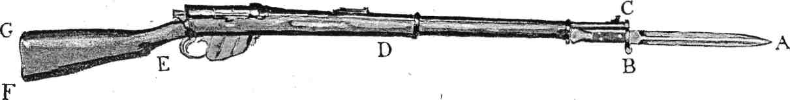

THE MAGAZINE RIFLE AND BAYONET.

A. Point. | A - B Edge | A - C. False Edge. | B - D. Forte.
D - E. Centre. | E - F. Butt. | F. Toe. | F-G. Heel Plate.

Our Weapon in Defence.
Next we must consider our weapon in its defensive aspect, and we must observe that it presents three great factors of defence. The blade, being the "foible," must never be so used. The first is that part of the stock which lies between the muzzle and the "balance," the part, that is, which rests in the advanced hand; it corresponds to the "Forte" of the sword, and by that name I shall call it; with this part the attacks of point are usually parried. The second is the "Centre," the part between the balance and the small—the part, in fact, between the two hands - and with it are parried certain ripostes of point, some of the cuts, and most of the strokes of the butt. The third is the "Butt," which parries both thrusts and cuts directed at the lower lines.
The Guard.
I must again call the attention of the reader to the necessity of avoiding any confusion between the two terms, "Guard" and "Parry," the latter being a distinctly defensive movement, while the former, the guard, is simply that posture which is at once the most ready for attack and the most secure for defence.
The feet should now assume a position similar to that used on guard in sabre play, excepting that the left foot should be in advance ; they should be placed well apart, the average distance between them being about twenty-four inches, but this must be regulated in conformity to the height of the man, the knees being well but not too much bent, so as to be supple and ready for movement in any direction ; the body upright but not stiff, and its weight equally distributed between the legs, so that there should be no more strain on one than on the other.
The left hand should hold the rifle just in front of the backsight (the backsight itself is placed exactly at the "balance," and it is an awkward thing to take hold of), the right hand of course grasping the small, and the point of the bayonet in line with the opponent's face.
Teachers and pupils must never forget that elasticity of limb is the main essential to success in wielding the bayonet, and the greatest care must be taken to avoid anything which may tend to cause rigidity; the hands, therefore, must hold the weapon somewhat lightly, a tight grip with the hands invariably causes stiffness in the wrists and arms.
The rifle should rest easily in the left hand, with the true edge in line with the centre knuckles, as a sabre is held, and in a medium guard, that is to say, not covering directly either outside or inside, but ready to parry promptly in any direction. When the bayonets are engaged on the inside the guard will be a Quarte Medium, and when on the outside a Sixte Medium.
I do not approve of engaging in a Quarte Guard with "opposition," as Chapitre recommends, because in such a position a very wide opening is shown on the outside in the region of the advanced forearm, which can be easily reached with a disengagement, and it is impossible to follow this movement with a circular parry as is done in foil practice; the only parries practicable with the bayonet are the simple ones, and these are the most easily effected from this Medium Guard.

PLATE II – The Guard

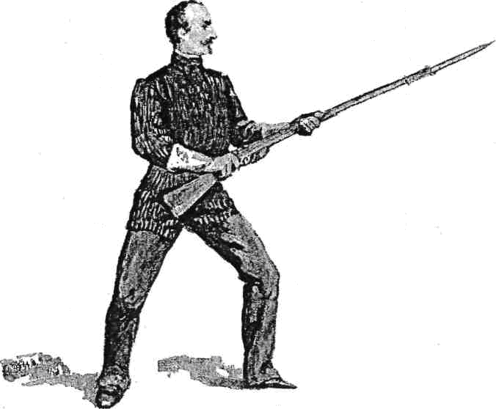

The Resting Guard.
Draw back the hands a little, and lower the rifle until the right hand rests on the upper part of the right thigh, and the back of the left hand and wrist on the left thigh ; the point of the bayonet is now directed a little low, and slightly off the line to the left, but it must be remembered that this guard, like the " Resting Medium" in 'Cold Steel' is only applicable when the opponent is out of reach, and its object is to afford repose to the muscles in order that they may be the more ready for active operations when fighting distance has been gained.
The Volte.
This must not be confounded with the old-fashioned movement so named in small-sword fencing, which was designed to remove the body from the direct line, and so avoid a sword thrust; the Volte I propose, which is nearly that of Chapitre, is intended simply to effect a change of front in order to face a rapid " traverse" on the part of the opponent, or to meet any other sudden flank attack. It is executed as follows:

To the Right— Volte. | Turn to the right on the toes of the advanced foot, describing a quarter circle backwards with the rearward foot from right to left, which will bring it behind the other again in the position of "Guard."
To the Left—Volte. | Turn to the left on the toes of the advanced foot, describing a quarter circle backwards from left to right, and bring it to the position of “Guard."

These movements effect an immediate change of front to right or left, without in any way disarranging the position of body or weapon.

Change Guard.
This, I think, is a more appropriate name for the movement than that of "Change Arms," and certainly it is a quicker mode of reversing the position of Guard from right hand to left hand than is the "Change Arms" ordered in the authorised manual of 1889, whether employed in the set lesson or in loose play; I deduce it from my changes between the Quarte and Tierce Guards of the "Great Stick" exercises in 'Cold Steel.' These changes are effected on the move, either advancing or retiring.

Change Guard (from right to left) Retiring.
Turn on the toes of the right foot, using them as a pivot, and retire the left foot about twenty-four inches behind it; the right toe will now point to the front and the left toe to the left. At the same time extend the arms, with the rifle in a horizontal position, sufficiently to allow the heel plate to be quite clear of the body, and pass it across to the left side without shifting the hands, the right hand passing underneath the left forearm; then seize the balance with the right hand, and the small with the left. We have thus assumed the “Guard" for the left-handed lessons or play, which in every way corresponds to the ordinary "Guard" we have just quitted, and which we may name the Left Guard,

Change Guard (from left to right) Retiring.
Turn, on the toes of the left foot, and bring the right foot behind it, the left toe pointing to the front and the right toe to the right; extend the arms as before, and pass the rifle across to the right side, the left hand passing under the right forearm, seize the balance with the left hand, and the small with the right. You are now in the position of the original Guard

Change Guard (from right to left) Advancing.
Turn on the toes of the left foot, bringing the right foot forward in front of it, passing the rifle to the left as before, and come to Left Guard.

Change Guard (from left to right) Advancing.
Turn on the toes of the right foot, bring the left foot forward in front of it, pass the rifle across to the right, and come to Guard.
It is a pity that the military authorities should have abolished the "About" of Angelo's Exercise, which was done by turning to the rear on the heels without moving off the ground, changing the hold pf the musket, and assuming the changed Guard facing to the rear. This movement, although not applicable in a set lesson, might be of infinite service in a melee.

__________

The movements of Advancing, Retiring, Traversing, Timing, Passing, &c., are all fully explained in 'Cold Steel,' and therefore a repetition of them here would be superfluous.

THE POINT.
The lessons should now be given individually, the master having the entire front of his body protected by a stout plastron.
The bayonet, when regarded as a weapon pointed only, must be recognised as, as it were, a two-handed small sword, and thus it must be subject to rules of a somewhat similar description, and in wielding it both hands must share in the work of its manipulation, as in the Great Stick Play, and neither hand should ever be used exclusively as "lever "or "fulcrum" as the writer of the Bayonet Exercise of 1889 has laid down.
We have now to observe the four divisions of the body, or lines of attack, as they appear when on Guard.
First, the Upper Inside, which corresponds to the Quarte line of foil fencing; and is on the right of the rifle above the hands.
Second, the Upper Outside or “Sixte “line, on the left of the rifle, above the hands.
Third, the Low Inside or “Septime “line, on the right of the rifle, below the hands.
Fourth, the Low Outside or “Seconde" line, on the left of the rifle, below the hands.

The attack, whether with point or edge, should always be made with the “allonge," or extension, and never, except at a mounted man, with the " developpement" or full lunge, on account of the tendency to loss of balance, which, with a hastate weapon the full lunge always entails.
In bayonet fencing there are five thrusts, namely, the Thrust, the Prime-thrust, the Throw, the Full Throw, and the Shorten Arms, which I will explain in the following lesson:

On Guard. | Fall back, by retiring the right foot,  to the position of Guard, as above described
Prove Distance. | Extend the rifle, until the point touches the right breast of the master.

The weapons must now be crossed in the Quarte Medium, the point of juncture being just below the Cross Guard.

Thrust | Advance the rifle smartly in a horizontal position, above the height of the shoulder, barrel uppermost, to the full extent that the arms will allow, until the point strikes the breast of the master on the upper inside line, at the same time completing the extension by bracing the right knee.
Guard. | Withdraw the point, and come to Guard.
Prime-thrust | Raise the rifle, sling uppermost, the butt and right hand to be as high as the right ear, and the back of the hand towards it.
Two. | Deliver the thrust, with the sling still uppermost, at the upper inside line.
Guard. | Withdraw the point, and come to Guard.
Throw. | Advance the point as far as the extension will permit, opening the advanced hand, and allowing the rifle to glide over the palm of it, striking the breast of the master on the upper inside line; the left hand will now be against the trigger guard, and must not be moved from its position, but must be ready to resume its proper hold instantly on the completion of the thrust, or in the event of the thrust being parried.
Guard. | Withdraw the point, and come to Guard.

The "throw" here recommended is the same as the "Glisse de l'Arme" of Gomard and Chatin, and against an opponent on foot it is the only real safe one; it should be, however, but sparingly used; while the full throw, as mentioned by Angelo, and known to the earlier writers as "jet de 1'arme," "coup lance," or ' coup lache," in which the left hand quits the rifle altogether, should be reserved for use against a mounted man.
The absolute necessity of keeping the left hand immediately underneath the rifle in effecting the “throw,” ought to be thoroughly impressed on the pupil; my experience with bayonet-fencing, which extends over more than thirty years, shows me that men are naturally too much inclined to let go altogether with the advanced hand, so that extra care should be taken to correct the tendency.

Shorten Arms | Bring the rifle down to a horizontal position, with the point direct to the front, carry it back to the full reach of the arms, and about level with the waist, the barrel to rest on the left forearm; and brace the left knee.
Thrust. | Deliver the point as before.

The Shorten Arms partakes to a certain extent of the nature of a "guard," it being the position best adapted for giving point at an enemy who has advanced within measure; the attitude of the arms is less stiff than that of Angelo, who, according to his illustration with which his letterpress does not entirely accord, shows the arms and the musket at the height of the shoulder.

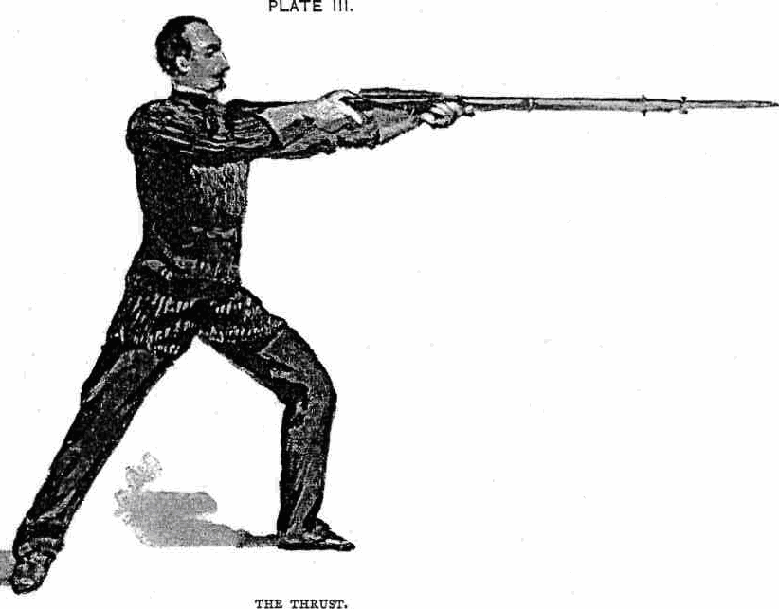

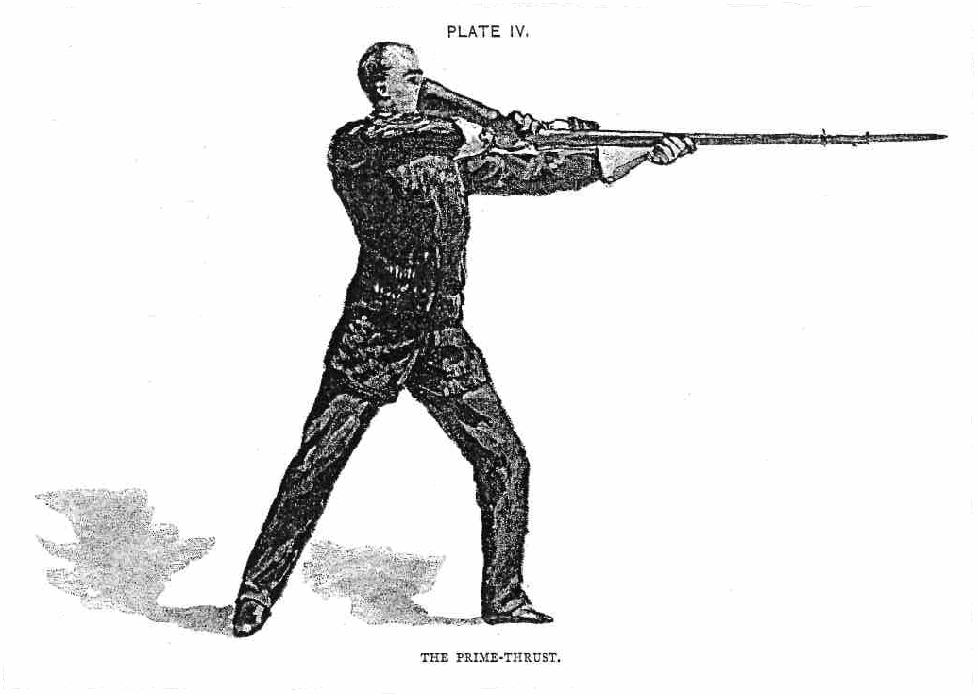

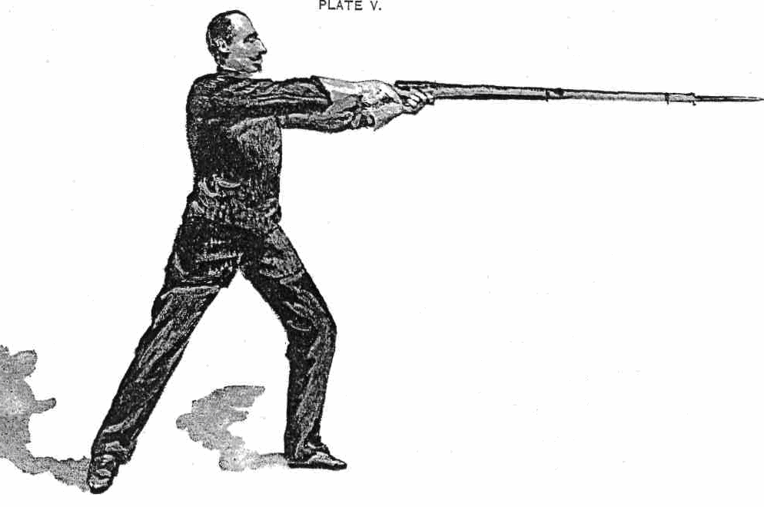
THE THROW

PLATE VI

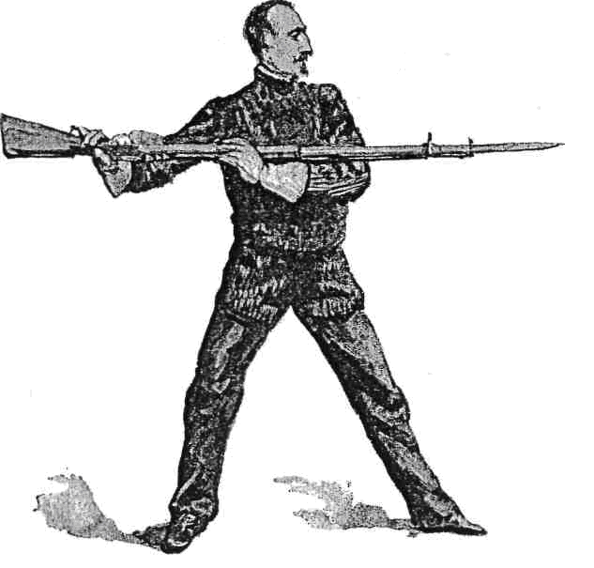
THE SHORTEN ARMS

Change of Engagement, or of Line.
This is a new engagement, formed on the opposite line by dipping the point underneath and close to the opponent's weapon, and joining it again on the other side.

Disengagement and Derobement.
These two movements are closely allied, in fact it is only of late years that the distinction has been recognised ; the purpose of both is, to take advantage of some opening for attack shown in a line other than that of the present engagement.
The Disengagement is an attack made by changing laterally, that is, from inside to outside or the reverse, by passing the point underneath and as close as possible to the opponent's forte, following instantly with a straight thrust in the opposite line.
The Derobement is made by changing from the upper to the lower line, and vice versa, when that line happens to be covered, following immediately with a straight thrust.

To these I shall call further attention after the lessons of parries against point.

Cut Over.
Raise the bayonet and pass it over the opponent's point, directing the thrust at the high line on the opposite side; this can only be done when the opponent's point is a little high.
When all these thrusts have been well learned, the master must give the order “Change Guard," when the lesson will be performed from the left guard.

PARRIES AGAINST POINT.
As there are four lines of attack with the point, so there are, according to all the received rules of the Art of Fencing, at least four simple defences or parries, that is to say, one for each line; their names are :
Quarte, which defends the high inside line.
Sixte, which defends the high outside line.
Septime, which defends the low inside line.
Seconde, which defends the low outside line.

In forming these parries, I adhere mainly to the instructions contained in my former work, ' Bayonet-fencing and Sword practice.' In their execution, care must be taken to ensure the greatest possible flexibility of the limbs, especially of the arms and shoulders.
It scarcely need be explained that in all parries, whether against a thrust or a blow, the attack must be received on the woodwork of the rifle, and never on the barrel.
To carry out the lessons of the parries, I place the master (M.) and the pupil (P.) opposite to each other, proceeding with the instruction as I did in 'Cold Steel.' They will engage, crossing their weapons in a quarte medium.

M. | P.
Thrust (at the upper inside line). | Parry Quarte, by passing the rifle slightly to the right, and so causing the opponent's weapon to glide off the forte; the point of the bayonet must not be allowed to deviate from the direction of the opponent's face.
On Guard.
Disengage and thrust (at the upper outside line). | Parry Sixte, by passing the rifle a little to the left,  turning the edge just enough to the left to allow the woodwork to meet the opponent's blade, by allowing the rifle to revolve in the left hand, and making a light springy beat on the opponent's weapon near the point, taking care to recover instantly from any deviation of the point from the direct line.
On Guard.

M. | P.
Derobe and thrust (at the low inside line). | Parry Septime, by lowering the point, and passing the rifle slightly to the right, the point to be kept in line with the opponent; this will parry a thrust at the low inside line, or will arrest a disengagement.
On Guard.
Engage in Sixte Medium. Derobe and thrust (at the low outside). | Parry Seconde, by lowering the point, turning the sling up, and carrying the rifle a little to the left, making a slight beat on the opponent's, weapon, as in the parry of sixte.
On Guard.

These parries must also be practised from the left guard.

PLATE VII

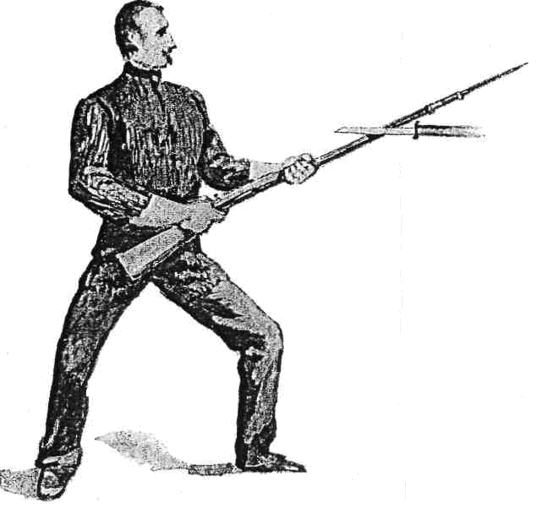
THE PARRY OF QUARTE

PLATE VIII

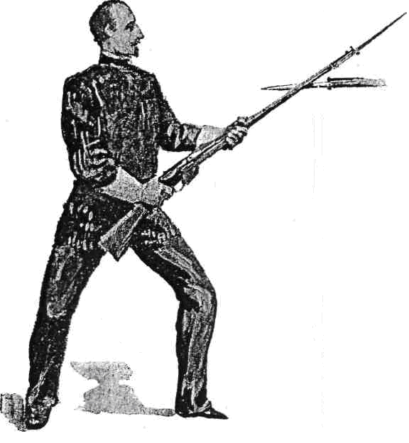

THE PARRY OF SIXTE

PLATE IX
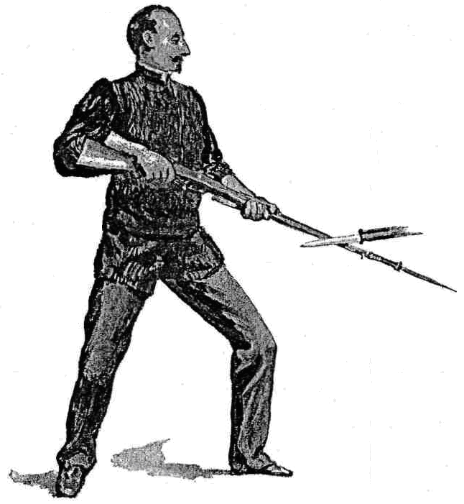
THE PARRY OF SEPTIME

PLATE X

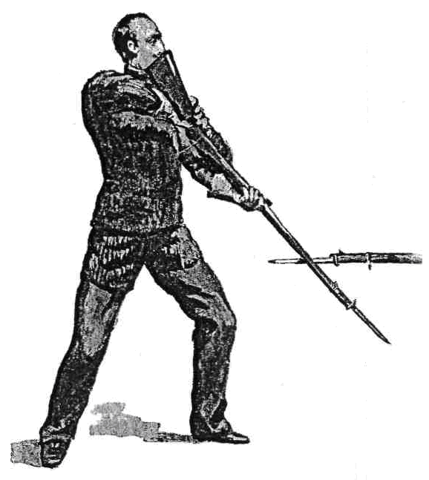

THE PARRY OF SECONDE

ADVANCED LESSONS.
Simple Attacks and their Parries, with one Riposte.

When the riposte is executed by the pupil the master should usually allow himself to be touched, but when he himself makes it he should be very careful to cause the pupil to form the proper parry.

Engage in Quarte Medium.
M. | P.
Thrust | Parry quarte, derobe, and thrust low.
Parry Septime.
On Guard.
When the pupil performs this in a satisfactory manner the lesson must be reversed, when P. will commence.
M. | P.
Derobe and thrust low. | Parry Septime, thrust high.
Parry quarte.
On Guard.
Reverse the lesson.

M. | P.
Disengage and thrust | Parry sixte, thrust high.
Parry sixte.
On Guard.
Reverse the lesson.

M. | P.
Disengage and thrust. | Parry sixte, derobe, and thrust low.
Parry seconde.
On Guard.
Reverse the lesson.

M. | P.
Cut over and thrust. | Parry sixte, disengage, and thrust.
Parry quarte.
On Guard.
Reverse the lesson.

Engage in Sixte Medium.
M. | P.
Cut over and thrust. | Parry quarte, derobe, and thrust.
Parry Septime.
On Guard.
Reverse the lesson.

These lessons should be practised also on the Left Guard.

Attacks on the Weapon.
Of the various movements of this class used in foil-fencing there are but three which I consider applicable to the bayonet. Their object is, primarily, to gain an opening by force; and, secondly, as feints employed in conjunction with some other movement to effect it by strategy. They are named the Pressure (pression), the Beat, or Dry Beat (battement sec.), and another kind of beat known in French as "Froissement" - a term for which we have no satisfactory equivalent in English, so I must perforce adhere to the French name, which I have already had to do with regard to the "Derobement."

The Pressure.
The weapons being joined in quarte or sixte medium, press slightly with the woodwork of your own rifle upon the opponent's blade or foible, and as his point deviates from the line deliver a straight thrust.
The Beat.
The Beat, or "Dry" Beat, is a purely lateral movement, it is effected by giving a smart springy rap to the opponent's blade or foible in order to drive his point out of line; it is followed, of course, by a direct thrust at the opening thus made.
The Froissement.
This movement, of the nature of the Beat and also of the Pressure, assisted by a movement in the form of a "Coule," is effected by striking the opponent's weapon sharply with a downward gliding motion. It is much more forcible than the "dry" beat; it must be followed instantly by the direct thrust.

In all these attacks on the weapon, care must be taken that the point does not deviate from the direct line.
The Feints.
In my earlier book, 'Swordsmanship and Bayonet-fencing,' I recommended that in effecting the feints the point should be gradually advanced, so that the feint and the real attack should be, so to speak, one continuous movement. In those days this was in common use, but, as far as the foil is concerned, it has now become obsolete : it is, however, still applicable to the bayonet, especially in a system which does not recognise the lunge. The most useful feints are the following:-

Engage in Quarte Medium.

Feint a straight thrust and disengage (to deceive quarte). | Advance the point slightly to make me think that you intend a straight thrust, and as I parry quarte, disengage and send the thrust home in the opposite line.
Feint a thrust and derobe (to deceive quarte). | Feint a thrust as before, and on my parry of quarte drop the point to the lower line and thrust home
One two (to deceive sixte). | Disengage, advancing the point a little, and on my parry of sixte disengage back again and thrust in the quarte line.
Under and over (to deceive septime). | Feint a low thrust, and on my parry of Septime deliver the point high.
Thrust, and one two (to deceive quarte and sixte). | Feint a thrust, I parry quarte; deceive it by disengaging, on which I parry sixte; disengage again, and thrust home in the quarte line.
One two three (to deceive sixte and quarte). | Disengage, I parry sixte ; disengage again, I parry quarte ; deceive it by disengaging a third time, and thrust home in the sixte line

Change to Sixte Medium.
Thrust and disengage (to deceive sixte). | Feint a direct thrust, and as I parry sixte, disengage and thrust home in the quarte line.
Thrust and derobe (to deceive sixte). | Feint a direct thrust, and as I parry sixte, drop the point and thrust home in the low outside line.
One two (to deceive quarte). | Disengage, and as I parry quarte, deceive it by disengaging again, and thrusting home in the quarte line.
Under and over (to deceive seconde). | Feint at low line, and as I drop my point to parry, derobe and thrust home in the high line.
Thrust and one two (to deceive sixte and quarte). | Feint a thrust, I parry sixte; disengage, I parry quarte; deceive it and thrust home in the sixte line.
One two three (to deceive quarte and sixte.) | Disengage, I parry quarte; disengage again, I parry sixte; deceive it, and thrust home in the quarte line.

Engage in Quarte Medium
Cut over and disengage (to deceive sixte). | Pass your bayonet over my point, I parry sixte; deceive it by disengaging and thrusting home in the quarte line.
Cut over and derobe (to deceive sixte). | Pass your bayonet over my point, I parry sixte; deceive it by derobing, and thrust home low outside
Cut over and one two (to deceive sixte quarte). | Pass your bayonet over my and point, I parry sixte; disengage, I parry quarte; deceive it, and thrust home in the sixte line.

Change to the Sixte Medium, and execute the feints from that line.
Engage in Quarte Medium.
Press and disengage (to deceive quarte). | Press my blade slightly, I resist this in the form of quarte; disengage, and thrust in sixte.
Press and derobe. | Press my blade slightly, I resist; derobe and thrust low.
Press and one two (to deceive quarte and sixte). | Press slightly, and on my resistance disengage, I parry sixte; deceive me by disengaging again, and thrust in the quarte line.
Beat and disengage (to deceive quarte). | Give a light "dry" beat on my blade, I resist in the form of quarte; disengage, and thrust in the sixte line.
Beat and derobe. | Give the dry beat, I resist it; derobe to the lower line and thrust.
Beat and one two (to deceive quarte and sixte). | Give the dry beat, I resist it; disengage, I parry sixte; disengage again, and thrust in the quarte line.
Change, beat, and derobe. | Change to sixte and instantly beat, I resist in sixte; derobe, and thrust low outside.
Change, beat, and disengage | Change to sixte and beat, I resist in sixte; disengage and thrust in the quarte, line.

Repeat the above movements from the sixte engagement.
As soon as the pupil is able to effect these compound attacks with precision, the master must cause him to practice them from the left guard.
I shall now proceed to apply the more simple of these feints, in combination with the returns, in the form of
Compound Ripostes, or Ripostes preceded by Feints.
Engage in Quarte Medium.
M | P.
Thrust. | Parry quarte, disengage, and thrust in sixte line.
On Guard.
Thrust. | Parry quarte, feint one two, thrust in the quarte line.
On Guard.
Thrust. | Parry quarte, feint under and over, thrusting in quarte.
On Guard.
Thrust. | Parry quarte, feint a straight thrust and derobe, thrusting in lower line.
On Guard.
Disengage and thrust. | Parry sixte, disengage, and thrust in quarte line.
On Guard.
Disengage and thrust. | Parry sixte, derobe, and thrust low outside.
On Guard.
Disengage and thrust. | Parry sixte, feint one two, thrusting in sixte line.

COMBINATIONS.
Engage in Quarte Medium.

M. | P.
Thrust. | Parry quarte, derobe, and thrust low.
Parry Septime, thrust high. | Parry quarte, disengage, and thrust.
Parry sixte.
On Guard.
Reverse the lesson.

Thrust low. | Parry Septime, thrust high.
Parry quarte, disengage, and thrust. | Parry sixte, derobe, and thrust.
Parry seconde.
On Guard.
Reverse the lesson.

Disengage and throw. | Parry sixte, and thrust.
Parry sixte, disengage, and thrust. | Parry quarte, derobe, and thrust.
Parry Septime.
Guard.
Reverse the lesson.

Press. | On the pressure, disengage and thrust.
Parry Septime,(arresting his movement), and thrust high. | Parry quarte, disengage and thrust.
Parry sixte.
On Guard.
Reverse the lesson.

Press, disengage and thrust. | Parry sixte, disengage and thrust
Parry quarte, thrust low. | Parry Septime, thrust high.
Parry quarte.
On Guard.
Reverse the lesson.

Froisse, and throw. | Parry quarte, thrust low.
Parry Septime, thrust high. | Parry quarte, disengage and thrust.
Parry sixte.
On Guard.
Reverse the lesson.

Beat (dry), disengage and thrust. | Parry sixte, disengage and thrust.
Parry quarte, one two, and thrust | Parry quarte, feint under, thrust over.
Parry quarte.
On Guard.
Reverse the lesson

Change, froisse and throw. | Parry sixte, one two, and thrust.
Parry sixte, disengage and thrust. | Parry quarte, feint a thrust, and derobe.
Parry Septime.
On Guard.
Reverse the lesson.
Change, beat, disengage and thrust. | Parry quarte, thrust low.
Parry Septime, thrust high. | Parry quarte, feint a thrust, and disengage.
Parry sixte.
On Guard.
Reverse the lesson.

These combinations must be performed also from the left guard.

PLATE XI
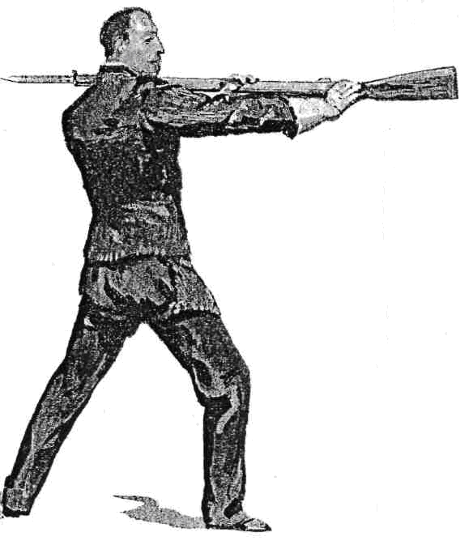

THE BUTT-THRUST

THE EDGES.

At the suggestion of the late Lord Strathnairn, I wrote in 1866 a short system of fence for the musket and sword-bayonet, which in 1867 I incorporated in my treatise, 'Swordsmanship and Bayonet-fencing.' In the following pages I shall adhere mainly to the rules therein laid down, adding certain matter which I deduce from my sabre lessons in ' Cold Steel.'
Circumstances occur but seldom when a direct attack may be safely made with the edge, and then only at the advanced hand or forearm when the opposing point is a little out of line; but the cut forms a powerful auxiliary in riposte when an overstrong parry on our part may have deflected our point somewhat away from the presence of our antagonist, as the Italians term it "fuor di presenza" Such deviation from the direct line is, in the case of a weapon pointed only, a grievous and very dangerous fault, as it renders a quick riposte impossible, while at the same time it leaves us open to a remise if we are engaged with an active man; but, with our present arm, a cut deftly substituted for the thrust in such a case makes our return hit a certainty.
I propose now six cuts, instead of four, as I formerly advised: they are two diagonal downwards, two diagonal upwards, and two vertical cuts, one up and the other down, at the advanced hand and arm.
Cuts at the body are not, I think, advisable with a blade so short as ours, but they should be aimed at parts less likely to be protected by thick clothing.
The cuts, when delivered, should be finished with a drawing motion to make the edge bite ; they are executed as follows :-

Cut 1 | is given diagonally downwards, from right to left, at the left cheek, or neck, with the false edge.
Cut 2 | is given diagonally downwards at the right cheek, or neck, from left to right, with the true edge.
Cut 3, | or the "Coup de Jarnac," is given diagonally upwards, from right to left, at the sinews behind the advanced knee, with the false edge.
Cut 4 | is given diagonally upwards, from left to right, at the advanced knee, with the true edge.
Cut 5 | is directed vertically downwards at the advanced hand, or arm, with the true edge.
Cut 6 | is directed vertically upwards at the advanced hand, or arm, with the false edge.

These two latter cuts, being vertical, may be made on either the inside or outside line.

In this part of my system of bayonet-play I think it necessary to introduce a thrust with the butt, which I have derived from the " Ecole du Fantassin" of M. Gomard.

THE BUTT-THRUST.
Allow the bayonet to drop to the rear over the left shoulder, pass forward the right foot, and drive the heel plate like a battering ram into the opponent's face.
The same French author also recommends a Back Butt-thrust {coup de crosse en arriere) ; this is not a thrust of fencing, but is intended to be used in a melee, when attacked from behind so suddenly and so closely that there is no possibility of bringing the rifle " about" in order to employ the point. Without moving the feet, turn the body and head to the rear, and with the full swing of the arms force the heel plate into the face of the assailant.

SUPPLEMENTARY PARRIES.

The Parry of Prime against Cut 1.
Cut1, when returned over the rifle after having parried quarte, is very difficult to stop ; it must be parried with Prime, a movement which corresponds to the " High Prime " of the sabre (vide 'Cold Steel'). Drop the point and raise the butt, until the weapon is nearly vertical, but with the point inclined a little forward, and turn the stock to the left front, allowing the rifle to revolve in the left hand ; the right hand, which holds the small, must now be as high as the top of the head, so that you can look at the enemy underneath the wrist; the left, or advanced hand, must be slided nearly to the muzzle ; and the cut must be received on the centre, between the hands.
The Parry of High Septime against Cut 2.
Cut 2, when returned over the rifle after having parried sixte, is even more difficult to stop than the corresponding cut on the other side, being, I think, more rapid, and certainly much more powerful; it must be parried with High Septime. Drop the point and raise the butt until the weapon is nearly vertical, but with the point a little advanced, and turn the stock to the right front; the right hand, holding the small, must be as high as the top of the head, and the left hand must be slided nearly to the muzzle, and Cut 2 must be received on the centre.
The Parry of Under-Sixte against Cut 3.
Cut 3, which is directed at the outside of the advanced knee after having parried rather wide in Septime, must be parried with the Under Sixte. Raise the point and drop the butt to the left front, shift the fingers of the right hand (as suggested by Selmnitz) in such a manner that the small shall be momentarily held between the thumb and the centre joint of the forefinger, and receive Cut 3 on the butt, and the instant the parry is effected the proper grip must be resumed; it will be found that as the riposte is being given the fingers of the right hand will readily resume their normal position, just as is the case after the parry of " High Octave " in Sabre Play {vide ' Cold Steel').
This parry of under-sixte is also extremely useful, as shown by M. le Capitaine Chatin, a French officer, in his excellent little work 'L'Escrime a la Baionnette,' published in 1855, for parrying thrusts at the lower line, especially the outer, the attacking point being dashed aside by a sweep of the butt from right to left.
The Parry of Under-quarte against Cut 4.
Cut 4 is parried with the butt in under-quarte. Raise the point and drop the butt to right front, shifting the grip of the right hand as before, and receive on the butt.
I have named these two parries under-quarte and under-sixte, to distinguish them from low-quarte and low-sixte, which would relate to the forte of the weapon.

To Defend the Advanced Hand from Cut 5.
The only secure method of meeting this vertical downward cut at the advanced hand is by slipping it back and delivering a time-thrust in the form of a throw.

To Defend the Advanced Hand from Cut 6.
For this there are two defences; first, by the parry of horizontal quarte, bring the rifle horizontally across the body, with the stock downwards, and receive Cut 6 on the centre; second, by shifting the hand and delivering the time-throw.

The parries of centre-sixte and centre-quarte are sometimes useful in a "phrase d'armes;” they are formed with the point raised, the parry being effected with the centre, or the part of the rifle between the two hands.
The Parry of Horizontal Prime against the Butt-thrust.
Bring the rifle horizontally across the body, the bayonet pointing to the left; turn the stock upwards, and, with the centre, force up the attacking butt so as to be clear of the head.
This thrust may on occasion be parried with quarte or sixte.
These cuts and parries should be practised on the left guard.

PLATE XII

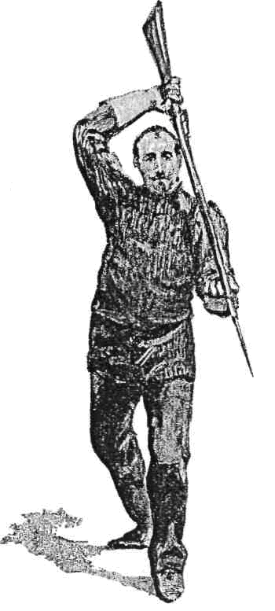
THE PARRY OF PRIME

PLATE XIII
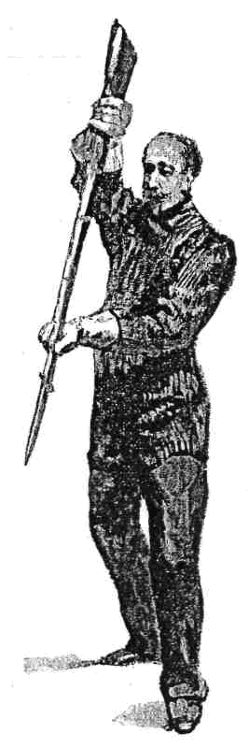
THE PARRY OF HIGH SEPTIME

PLATE XIV
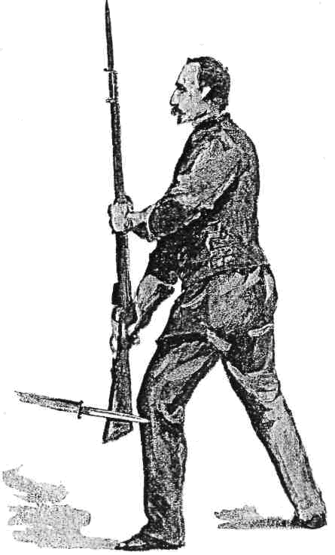
THE PARRY OF UNDER-SIXTE

PLATE XV
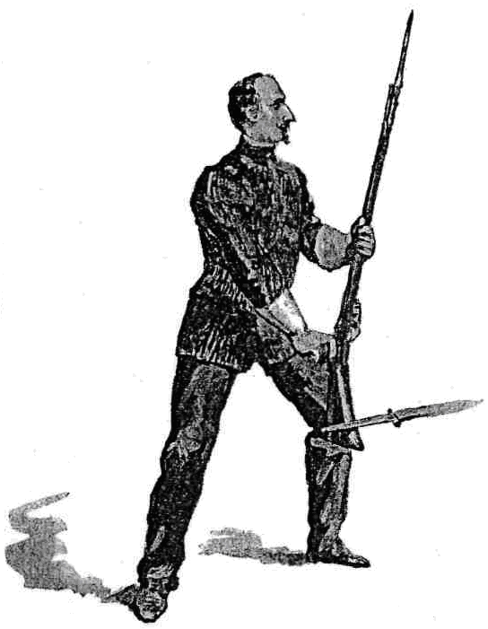
THE PARRY OF UNDER-QUARTE

PLATE XVI
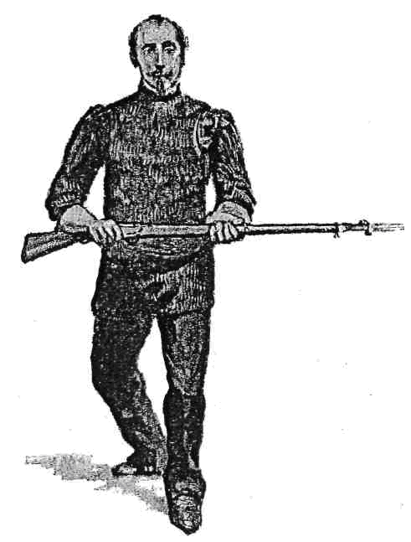
THE PARRY OF HORIZONTAL QUARTE

PLATE XVII

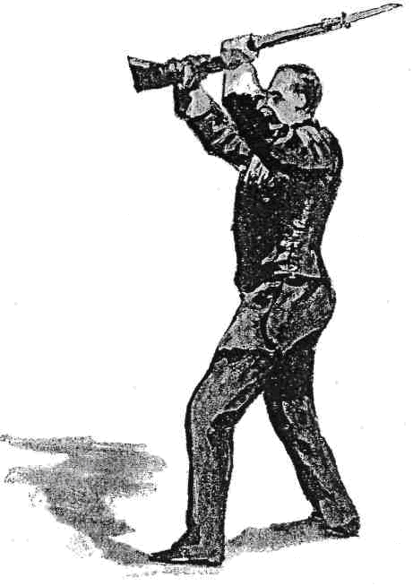
THE PARRY OF HORIZONTAL PRIME.

COMBINATIONS ON THE FOREGOING LESSONS.

Engage in Quarte Medium.
M. | P.
1. Thrust. | Parry quarte, cut 1 over the rifle.
Parry prime, thrust. | Parry seconde, cut 4
Parry under-quarte.
On Guard
Reverse the lesson.

2. Thrust. | Parry quarte, cut 1 over the rifle.
Parry prime, thrust prime. | Parry sixte or centre-sixte, cut 2.
Parry quarte.
On Guard.
Reverse the lesson.

3. Disengage and thrust. | Parry sixte, cut 2 over the rifle.
Parry high Septime, thrust low. | Parry under. Sixte, thrust butt.
Avoid by slipping.
On Guard.
Reverse the lesson.

4. Derobe and thrust low. | Parry Septime, cut 3.
Parry under-sixte, cut 2. | Parry high Septime, thrust low (by sinking down to it).
Parry under sixte.
On Guard.
Reverse the lesson.
5. Cut over and derobe. | Parry seconde, cut 4.
Parry under-quarte, cut 1. | Parry prime, thrust low (by sinking down).
Parry under-quarte.
On Guard.
Reverse the lesson.

Movements with Advanced Hand.

M. | P.
Cut 5. | Slip the hand back, and deliver the throw as a time hit.
Cut 6 | Slip the hand, and time as above.
Cut 6. | Parry horizontal quarte, and cut 2 over the rifle.
Cut 6. | Parry horizontal quarte, and thrust butt.

BUTT-FENCING.
Several Continental writers have advocated, from time to time, certain blows with the butt to be used in cases of emergency, but I have not as yet found among their works anything approaching to a system of attack and defence with that part of the weapon.
In 1882, however, I published in my 'Bayonet-fencing and Sword-practice,' a rudimentary arrangement of "strokes" and "stops;" this I shall now enlarge upon, applying to the "stops," or rather parries, the customary terms of fence to which I have systematically adhered, both in the earlier portion of this book and also in its predecessor, ' Cold Steel.'
There must arise, whether in a fight with sharps, or in a friendly contest in the fencing-room, occasions on which the combatants find themselves so close together that neither of them can, with anything like safety, attempt either to withdraw his person or disentangle his weapon. This I have often seen in a bout of play, and, indeed, more than once in public, when the men were so utterly nonplussed that they were obliged to separate by mutual consent - an arrangement easy enough in the mimic fight of the salle d'armes, but not quite so feasible in a life-and-death struggle in the field; and it is in such-like cases that the system which I designate "Butt -fencing" will be found most effective; indeed, a bold man who understands it thoroughly will be rather inclined to court a close, feeling that he has within his grasp a method of "Corps a corps" fighting which is superior to any method of "Shortening arms " ever yet invented.
The Attacks.
The attacks in butt-fencing consist of certain "strokes," which must be given with the sharp projecting "toe" only. A blow with this is very conclusive, and its force is felt even when it falls on a stout fencing - helmet; any injury is, however, obviated entirely by the use of the very simple padded butts which were devised according to my suggestions some years ago, and have been in use at the London Fencing Club ever since. If the stroke is given with any part other than the sharp "toe," it can do no harm beyond irritating the recipient, and making him perhaps a little more dangerous.
In addition to the strokes, we have the thrusts which I have already described, inflicted with the heel plate, these are similar to the "coups de crosse" recommended by Chapitre, who emphasises the fact of their being thrusts by connecting with them the command "Pointez."
These attacks must be made according as openings are discovered, and at parts of the person only on which blows with an obtuse weapon will tell seriously, such as the face and head, the " horseshoe," the points of the lower ribs, and behind on the kidneys ; they must all be given direct, as I think it will be found impossible to combine feints with them.

Guard.
I shall suppose the rifles to be crossed at their centres in the quarte position, this being the one in which the combatants are most likely to find themselves on coming to close quarters, and which, therefore, we must consider to be our " guard."
We must recollect, further, that, when once we have made up our minds to fight with the butt, we must keep close in and prevent our man from getting away, lest he should find the opportunity of "shortening arms" and treating us to his point.

Stroke 1.
Rapidly sink the point, raise the but; and deliver the stroke with the "toe" above the opponent's rifle, at his left cheek or temple.
Stroke 2.
Raise the point until the rifle is very nearly vertical, and drive the "toe" either into his "horseshoe" (the pit of the stomach), or the points of his lower ribs.

Stroke 3.
Pass forward the right foot, and deliver the toe behind the left ear; this is useful when, from the position of his rifle and left arm, you are not likely to succeed with stroke 1 or stroke 2.

Stroke 4.
Pass forward the right foot and deliver the stroke just below the ribs on the left rear.
The Thrust.
This movement is the same as the thrust previously described, save that, the combatants being close together, the step forward is unnecessary.

The Parries.
Against Stroke 1.
Raise the butt, throwing the stock upwards, into the form of prime, and receive stroke 1 on the centre.
Against Stroke 2.
Bring the rifle to the position of horizontal quarte, and receive stroke 2 on the centre.

Against Stroke 3.
Raise the rifle to a vertical position, in the form of sixte, the left hand to be as high as, and close to, the left shoulder, and receive stroke 3 on the forte.

Against Stroke 4.
Lower the butt, and bring the rifle to a vertical position, in the form of sixte, as above, and receive stroke 4 with centre-sixte between the hands.

Against the Thrust.
Bring the rifle to the position of horizontal prime, and force the opponent's butt upwards with the centre. The thrust may on occasion be parried with the forte in quarte or in sixte.
Stroke 2 may be used as a feint, in order to draw the horizontal quarte parry, and a drawing cut 2 be made at the right cheek.

PLATE XVIII
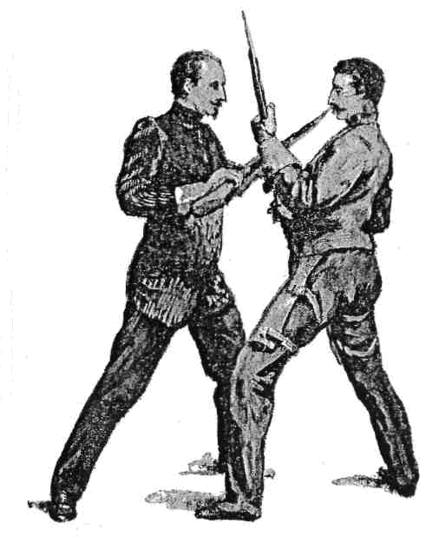
BUTT – FENCING. – THE GUARD

PLATE XIX
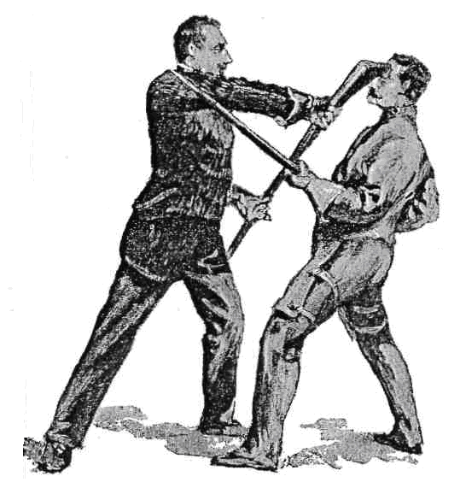

BUTT – FENCING. – STROKE 1.

PLATE XX
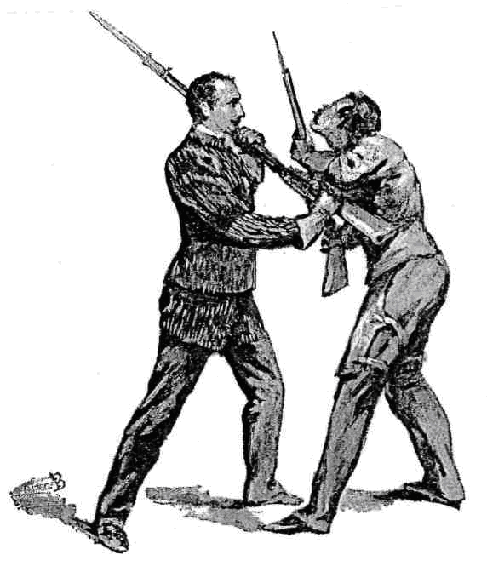
BUTT – FENCING. – STROKE 2.

PLATE XXI
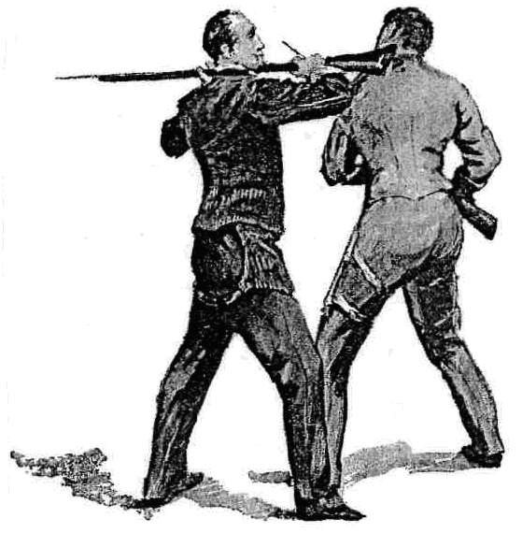
BUTT – FENCING. – STROKE 3.

PLATE XXII
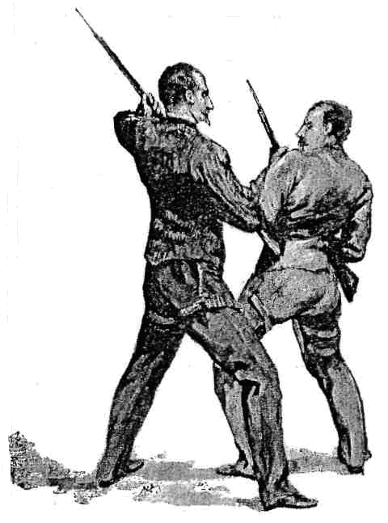
BUTT-FENCING. – STROKE 4.

PLATE XXIII
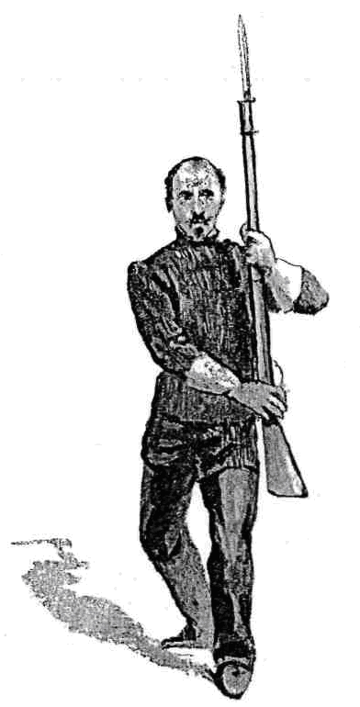

BUTT-FENCING. – POSITION IN PARRYING STROKES 3 AND 4, WITH SIXTE AND CENTRE-SIXTE.

COMBINATIONS OF STROKES, RIPOSTES AND CONTRE-RIPOSTES.

M. | P.
Stroke 1. | Parry prime, stroke 2.
Horizontal quarte, stroke 1. | Parry prime.
On Guard.
Reverse the lesson.

Stroke 2. | Parry horizontal quarte, stroke 1.
Parry prime, stroke 2. | Parry horizontal quarte.
On Guard.
Reverse the lesson.

Stroke 3. | Parry sixte, stroke 2.
Parry horizontal quarte and stroke 1. | Parry prime.
On Guard.
Reverse the lesson.

Stroke 4. | Parry centre sixte, stroke 1.
Parry prime, stroke 2. | Parry horizontal quarte.
On Guard.
Reverse the lesson.

Thrust. | Parry horizontal prime, stroke 2.
Parry horizontal quarte, stroke 1. | Parry prime.
On Guard.
Reverse the lesson.

COMBINATIONS FOR RIGHT GUARD OPPOSED TO LEFT GUARD.
I think it advisable now to record a few combinations intended to facilitate a combat with a left-handed man, in which M. will take the right guard and P. the left guard. When the lesson is reversed, P. will of course stand on the right guard and M. on the left.

M., Right Guard. | P., Left Guard.
Thrust outside high. | Parry sixte, cut at left cheek.
Parry prime, cut outside leg. | Parry under sixte, cut right cheek.
Parry quarte.
On Guard.
Reverse the lesson.

Thrust inside high. | Parry quarte, cut at right temple.
Parry horizontal prime, butt stroke at left ear. | Parry quarte, stroke 2 at ribs.
Parry horizontal quarte.
On Guard.
Reverse the lesson.

Thrust low. | Parry Septime, thrust low.
Parry under-sixte, cut at head. | Parry horizontal prime, thrust prime outside high.
Parry sixte.
On Guard.
Reverse the lesson.

Thrust low. | Parry Septime, thrust high.
Parry quarte, cut left cheek. | Parry high Septime, pass, and give the butt at the right cheek
Parry quarte.

THE ASSAULT.
The necessary personal equipment for bayonet-fencing is similar to that used in sabre play, with the addition of a stout fencing gauntlet for the left hand.
When leg pads are worn, hits should count as good ones on whatever part they may strike, but when the leg pads are dispensed with, no hit must be allowed at or below the knee, in order to obviate the danger of inflicting serious injury.
A time hit should only be counted good where it saves the giver from being touched at all; when both touch, and the intended time thrust is only a matter of half a second or so in advance of the other, it should not be counted, as both men would have been killed, but the two should be treated as exchanged hits or "coups fourres." A time hit at the advanced leg with any weapon is not to be recommended, and, indeed, should not be allowed at all; it would never be attempted with sharps, being far too dangerous.
When a hit is received, the player who receives it should acknowledge by dropping his point to the ground, quitting the hold with, and extending the left hand, palm uppermost; he who has given the hit should immediately recover to guard.
In loose play, the combatants must be especially careful to preserve due elasticity of joint and limb, by avoiding any pressure or contact of the hands or arms with the body, except, of course, in the case of the" Resting Guard."
In making the Assault, I am inclined to take the "Guard" with the point a little more horizontal than when performing the set lessons ; but, excepting when engaged against the sabre, the point must never be held in the low lines, a position which would attract a downward beat - and that, if successful, would most likely crush the barrel, and so ruin the rifle for shooting purposes, the preservation of which should be one of our first cares.
When the combatants engage with " opposition," that is, with the weapons crossed and covering either line, they should avoid any accidental or involuntary pressure upon the opposing rifle; pressure of this kind is exceedingly dangerous, as it lays them open to an attack by either "disengagement" or "cut over." Pressure, however, with the weapon under thorough control, may be resorted to as before described, both to force an opening, and as a feint to draw either responding pressure or a disengagement. Men engaged with this opposition should be ready, in case of disengagement, either to parry in the opposite line, or, what is still more baffling to the enemy, to arrest his movement by a parry in the corresponding low line - as, for instance, I engage in quarte with opposition, you disengage, and I, instead of allowing you to complete your attack and parrying it with sixte, stop your movement half way by the parry of Septime, and if you "derobe" on this and thrust high, I come up to quarte again, and so keep you captive on the inner lines, whether you will or no.
The Attack should always be commenced with point, excepting at the advanced hand, and this is not to be recommended unless the opponent's point is a little off the line; but in riposte, the edge is, as has been shown, very useful indeed, especially where the point has been allowed to deviate from the line, a breach of fencing rule which the Bayonet Exercise of 1889, practically speaking, enforces.
Engage always out of distance, and advance with little short steps, keeping the point always threatening the enemy; and if you find that he is given to retiring, pursue him steadily, securing always the ground he has lost in his retreat; and when there may be broken ground or other obstacle somewhere in rear of him, force him upon it by means of the traverse (see 'Cold Steel,' p.7). An opponent who is given to retiring much, will probably have recourse a good deal to the "throw," in which be ready with a strong parry, especially in the outer lines, as in them his recovery of the control of his weapon is more difficult; and advance upon him promptly before he can come to Guard. Where the antagonist seems inclined to come within measure, it is probable that he has the design to "Shorten arms" upon you, and therefore it may be wise to be beforehand with him by enclosing rapidly before he can draw his weapon sufficiently back, and treating him with the butt; if he does not understand "Butt-fencing," you can do what you will with him, and if he does understand it, you are on equal terms again.'
If the enemy is a bold man and given to attacking, it is better to await him in the defensive position, without, if possible, giving ground, and trusting mainly to your parry and riposte, this latter being the most certain hit in fencing with any arm. In point play it is well to break off the "phrase d'armes" after three or four thrusts have been exchanged, either by enclosing and coming to butt-fencing, or by springing back to guard out of reach, because, the weapon being a heavy one, the play after a rally of any considerable duration is sure to become disorganised, and the parries and ripostes will lose both their velocity and their precision.
In recovery after making an attack, come back to guard always with "opposition," that is to say, covering one line completely, after which resume whatever guard suits you best.
The time in which it is best to attack, is the time when you perceive that the enemy is meditating and preparing an attack upon you ; he will be thinking of nothing else, and will therefore be off his guard.

BAYONET AGAINST SABRE.
The decrease in the length of our bayonet must alter very considerably the relations between these two arms. Formerly, owing to the reach of our weapon, we were able to keep the swordsman at a great distance, while the momentum of our thrust was such as to oblige a parry on his part so strong as in most cases to prevent his giving his riposte with the required celerity. With the new arm, however, we are robbed of our main advantage, namely, reach, but we have a set-off for it in our two edges.
We are so near to the swordsman that he may, without much risk, deliver delicate little cuts with either of his edges at our advanced hand, and of this we should be extremely careful. Should he attempt them - and if he knows his business he most assuredly will do so - we must shift the hand and treat him to time thrusts, as an attempt at a parry, either in Horizontal Prime or Horizontal Quarte, would be too risky, as it would give him an opportunity of "commanding" our weapon on the pass at its centre; it is true that we might baffle his attempt to command by meeting him with either butt or edge, but I think the slip and time thrust are preferable.
He may, again, only feint a cut at the advanced hand, in order to draw our time thrust, which it is seen must be a "throw," and therefore our left hand must be in perfect readiness to resume instant and complete control of our rifle ; and never, in any case, must we allow ourselves to fall into the trap which the military authorities have set for us by their absurd order to withdraw the advanced hand entirely and "grasp the thigh " with it.
We must hold our point rather low, and a little away from the exact line of direction, but still not entirely deviated from the presence of the opponent, and we should keep our weapon slightly in motion, in order to promote elasticity, which will not be effected by holding the right hand fixed to the hip ; otherwise he will attempt, and very likely succeed, in engaging and controlling our weapon with his sword in tierce or seconde, and that done will inevitably pass forward and try to command our rifle at its centre, and therefore, if we allow him to move forward, we must meet him by passing forward also, and delivering a crushing No.1 stroke in his face with the butt. It is better, however, when he attempts to engage and cross our bayonet, to disengage and give him the point.
We ought to have the advantage of him, for we have three modes of attack, namely, point, edge, and butt, where he has only the edge and point; but it is incumbent upon us to be very well skilled in the practice of all three - and this the military authorities and their imitators, the Council of the Royal Military Tournament, have hitherto denied to us.

AGAINST THE LONG BAYONET.
A man armed with a weapon of the old-fashioned length - some six feet - has, it must be allowed, an advantage over us in reach, but we, with our shorter weapon, have that of lightness.
The opponent will naturally play to keep us at a distance, knowing that his foot or so of additional cold steel is then of most use to him ; he will probably also have recourse to extended "throws." We, with our shorter weapon, must trust at first entirely to our facility in parrying; we must advance by degrees within distance, keeping him captive, by the use of opposition in Quarte, supported by Septime, constantly on the inside, which is the easiest for us to defend; and we must take special care to prevent an attack on our advanced hand, while we must deliver such an attack upon him with our edge at the first opportunity. Or we may feint a cut at his hand, in order to draw the time thrust, which we must parry, and return with point, still creeping in upon him and getting well within distance; having attained which, we shall find that an attack by "shortening arms" will be much easier for us with our short blade than for him with his long one ; and, if this does not appear feasible, we can enclose still further, and commence action with the butt. Again, in retiring from the " corps a corps " position, it being supposed that our butt-fight has resulted in a drawn game, we shall be able to resume point play sooner than he will. In fact, excepting at the very first commencement of the encounter, when his long reach tells in his favour, a bold, active, determined man, armed with the shorter weapon, will have the advantage ; but to secure it he will need much more thorough instruction in the art of bayonet-fencing than that provided in the Bayonet Exercise of 1889.

.

